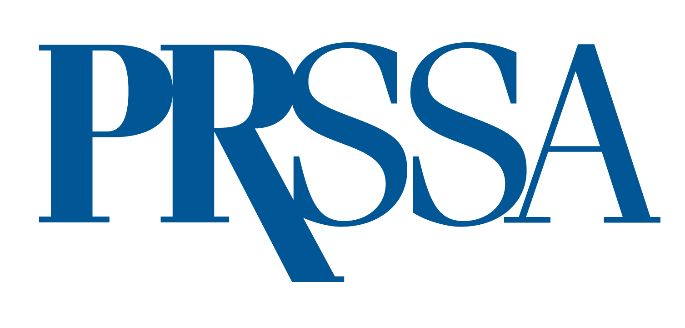
PRSSA 2024 Leadership Assembly
Frequently Asked Questions
March 7–9

Where is the 2024 Assembly being held?
The event will be held at the Renaissance Seattle Hotel, in Seattle, WA.

When is the Assembly?
Registration, the Resume Critique Session, Chapter Roundtable Discussions and the Welcome Reception will be held Thursday, March 7. Elections, sessions and networking events will be held Friday and Saturday.

Who is eligible to attend the Assembly meeting?
- Your Chapter’s official Assembly delegate (we suggest having your current president serve as the delegate).
- Incoming Chapter presidents or leaders

Who are categorized as representatives?
- Incoming Chapter presidents or leaders
- Delegates

Is there a registration fee for representatives?
No. PRSSA will cover one delegate and one incoming president or leader (if the incoming President cannot attend).

What are the representative responsibilities?
- Chapter Delegates are required to read and view all candidate nomination information prior to the official Assembly on March 8.
- Chapter Delegates and Incoming presidents (or Incoming Chapter leaders) must attend all Assembly events, unless the event is listed as optional or states otherwise.

When do the 2024–2025 National Committee officers begin their term?
June 1, 2024.

