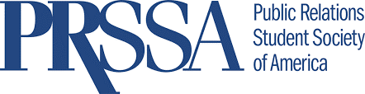

Membership Recruitment
Social Media Strategy

Content Creation
While there are message points available in the Chapter toolkit, each Chapter should generate their own creative content. The posts should complement your Chapter’s ongoing content. Creating items specific to each social media platform is important, since each has different best practices (listed below).

We recommend Chapters follow all PRSSA social accounts (@prssanational) and share posts made by the national PRSSA account. Don’t forget to use the hashtag #joinPRSSA on Twitter and Instagram.

Chapters can produce their own content and utilize any of the content published by PRSSA National.

Instagram Best Practices
Instagram rewards consistent posting and engaging with followers. The algorithm will prioritize content that receives more likes and comments. By creating consistent and quality posts, it gives opportunities for people to engage with you regularly. Instagram Stories is a great way to ensure your content gets seen by more followers on a daily basis.

Recommendations for this contest:
- Create your own content to compliment National content. Consider featuring Chapter members and Faculty Advisers
- Use a third-party app like Repost to share content by the national PRSSA account
- Showcase your membership via Instagram Stories and talk about the themed month, national events and more.
- Change the link in your bio to joinprssa.org during recruitment.
- Edit the Chapter’s bio to include #joinPRSSA
- Add #joinPRSSA to all content posted on Instagram (including Stories)
- Tag @prssanational in Stories for an opportunity to be shared on the national account
Sample Instagram Posts: Sample Instagram Stories:
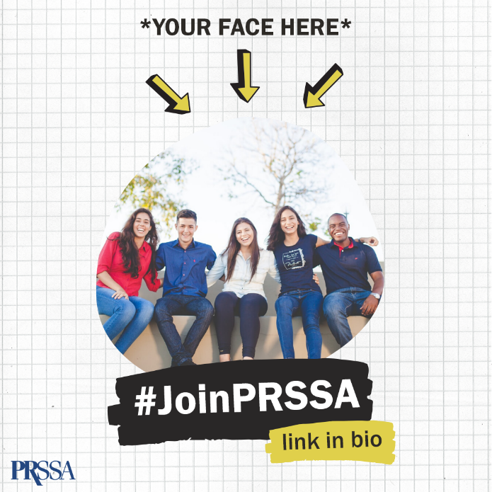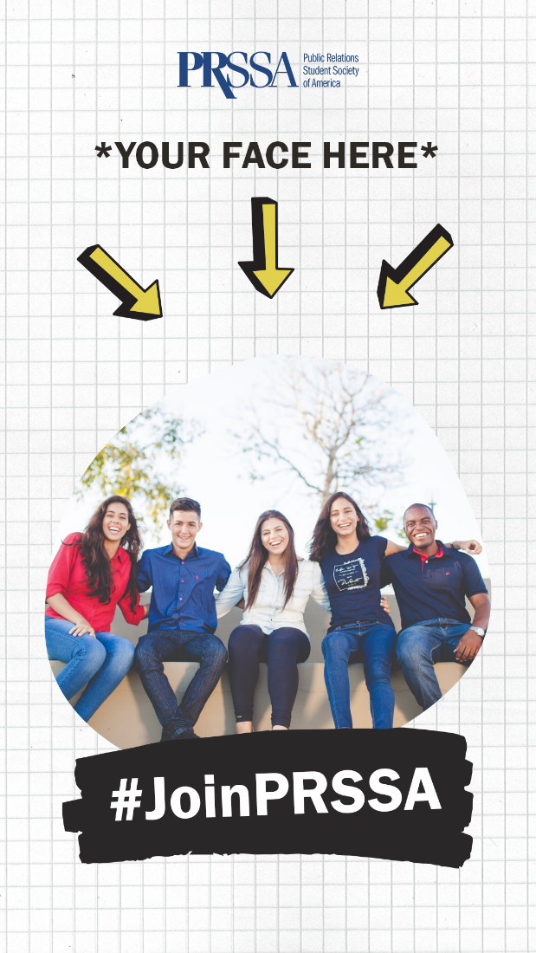

Facebook Best Practices
Facebook rewards posts that create conversation. Organic reach is generally limited to people who regularly engage with your content, but as you get more engagements, Facebook will widen the audience reach to include fans who might not regularly interact with you.

Recommendations for this contest:
- Create your own content to compliment National content. Consider featuring Chapter members and Faculty Advisers
- Share content directly from the national PRSSA account
- Edit your cover photo to align with PRSSA National during recruitment
- Create conversational content to invite members and non-members to engage
- Include the joinprssa.org link in your posts’ copy with a strong call-to-action encouraging membership
Sample Facebook Posts:
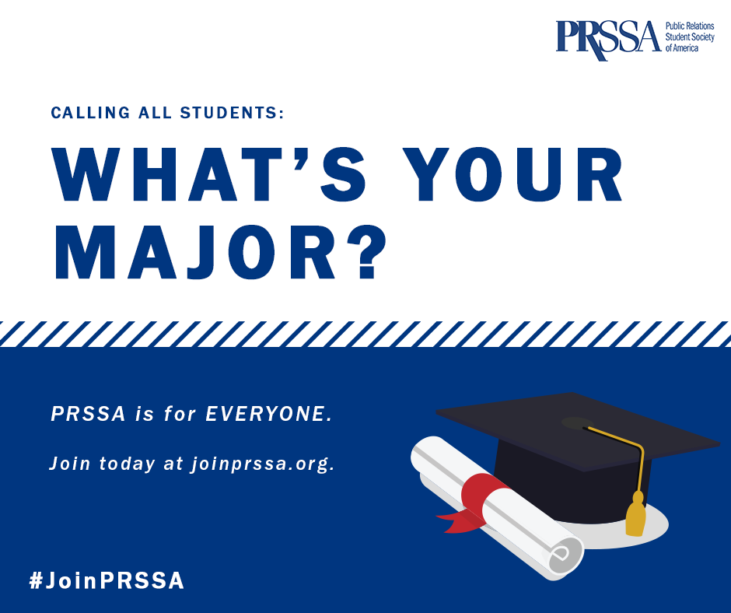

Twitter Best Practices
Twitter allows each user to select top tweets or latest tweets. If users select the latest tweets option, everything will be in chronological order. This means your Chapter’s content must be timely. If users select top tweets, this works much like Facebook and Instagram in its prioritization of timeliness, followed by engagement (retweets, clicks, favorites). It also takes into account how much a user engages with the account.

Recommendations for this contest:
- Create your own content to compliment National content. Consider featuring Chapter members and Faculty Advisers
- Retweet national PRSSA content
- Add #joinPRSSA to all tweets
- Edit your cover photo to align with PRSSA National

Sample Tweets:
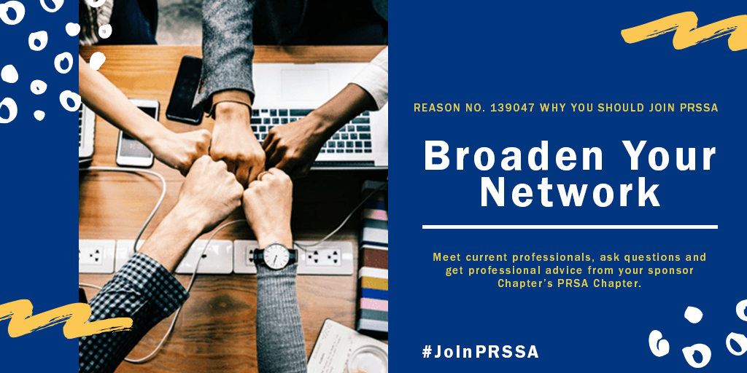

Frequency of Posting
Facebook and Instagram are algorithm-based, so you can easily post 1–2 times per week about becoming a PRSSA member and your engaged users will have a better chance at seeing the posts. The lifetime of a post on Facebook is around 4–5 hours and 21+ hours on Instagram. However, on Twitter, the lifetime of a post is closer to 20 minutes. Due to the fast-paced nature of the platform, it requires more content — at least once per day.

On the other hand, you should also give each post the space to breathe and attract the highest amount of organic reach. By posting back-to-back, you run the risk of cutting off the performance of the first post. Also, encourage your membership to comment, react or share it — this helps encourage the algorithm to prioritize your posts in newsfeeds.

