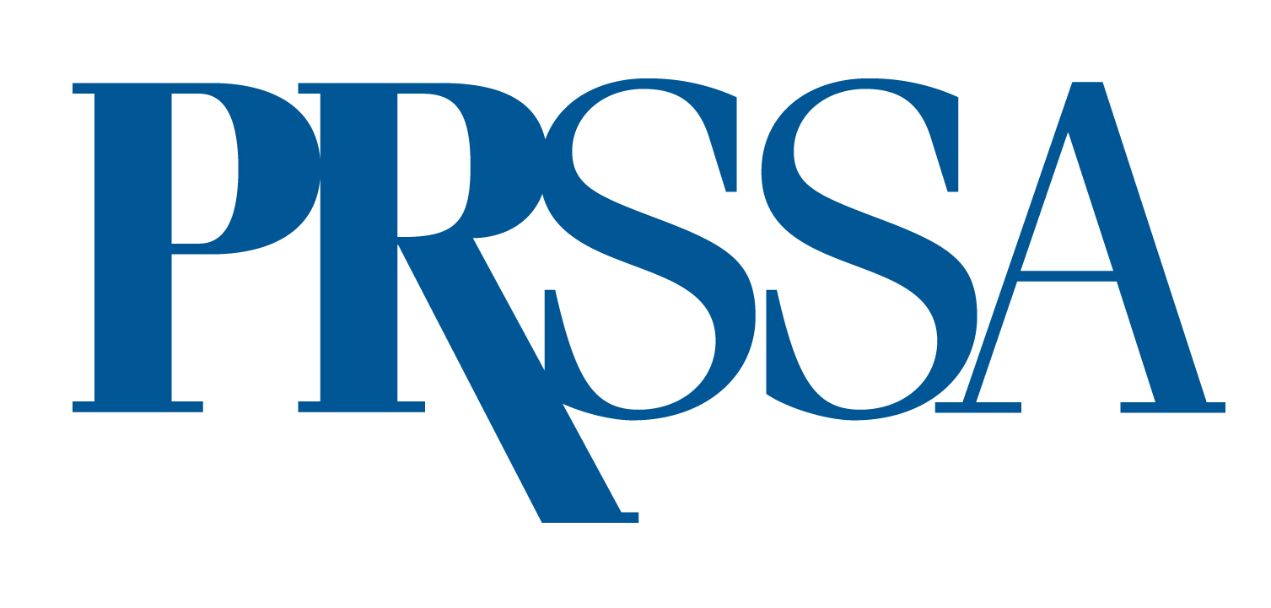

PRSSA 2023 Hall of Fame Award

To celebrate the success and progress of PRSSA and to acknowledge the contributions that PRSSA alumni have made to the public relations profession, the National Committee created the HALL OF FAME AWARD to be presented annually to one former PRSSA member. The recipient of this award will be an individual who has built a distinguished career in public relations and who continues to contribute to public relations education through PRSSA involvement. They must also be a current member of PRSA.

PRSA or PRSSA Chapters, Sections or the PRSA National Board may recommend one former PRSSA member each year. Individuals may be nominated on consecutive years but may only receive the award once. The PRSSA National Committee will review all materials and select the winner. All decisions are final and will be based on the content and quality of materials submitted.

The winner will be notified to provide the opportunity to receive the commemorative plaque at the Annual Awards Ceremony during the PRSSA 2023 International Conference in Nashville, Tennessee.

Application
To nominate someone for this award, submit the following materials:
- A completed application form
- A letter of recommendation from the nominator
- A copy of the nominee’s current resume

Make sure all materials are error free and thoroughly proofread. All application materials must be included as attachments and sent via email to ben.castleman@prsa.org by April 30. Incomplete or late applications will not be considered. (Reminder: The candidate must be a current member of PRSA.)

Nomination Form

Nominee PRSSA Chapter

Title Company

Full Address

Phone Email

Nominated By Email

