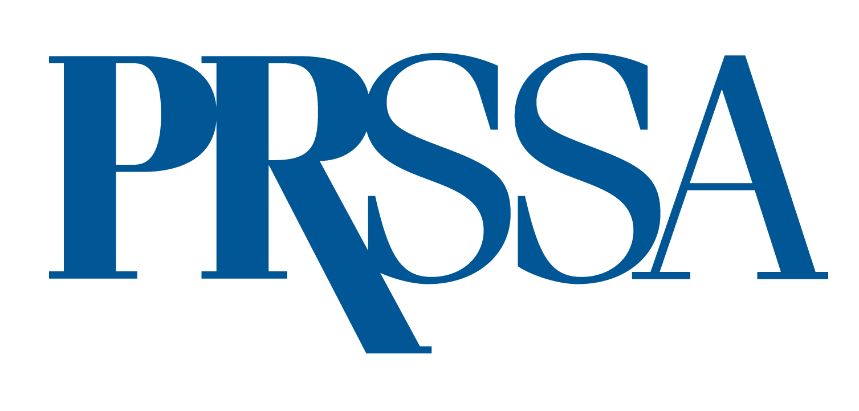

PRSSA 2025 Student-run Firm Awards
OUTSTANDING SOCIAL IMPACT PROJECT

The PRSSA Student-run Firm Award for Best Social Impact Project recognizes work done by Nationally Affiliated Student-run Firms during the academic year, May 1, 2024–April 30, 2025, that focus on helping the client make a difference in their community.

To be eligible, a project must have been implemented at least in part between May 1, 2024 and April 30, 2025. Entries tend to have better chances of winning near their completion, when evaluation against initial objectives can be measured. For a Student-run Firm to be eligible, it must have current National Affiliation status. If your firm’s National Affiliation application was recently submitted it must be approved before April 30, 2025.

To apply for a PRSSA Student-run Firm Award for Outstanding Social Impact Project, please submit the following:
- Three-page Summary. This concise summary is the most important part of your entry and should give the judges a thorough view of the complete project.
The summary should cover research, planning, execution and evaluation, and may include a situation analysis, research, goals, objectives, strategies, tactics and results.
- Samples. It will bolster your application to submit samples of work created to support the overall objectives of the project. Samples may include research data, collateral materials, schedules, photographs and videos.
If an element is online or a video, include screen shots in addition to links or video files. Do not assume judges will follow the link.
- 100-word Description. Include a 100-word description of your program. The description will be used to explain your entry if it receives the award.
- Application Form. Your application form, on Page 2 of this document, must be typed.

Entries must be letter-size, with at least a 10-point font and 1” margins. Entries will be accepted in PDF format, with accompanying files attached at the end of the PDF.
All application materials must be included as attachments and sent via email to ben.castleman@prsa.org. All entries must be received by April 30, 2025. Winners will be announced at the PRSSA 2025 International Conference and receive a certificate.

Application Deadline: April 30, 2025
PRSSA 2025 Student-run Firm Awards: Outstanding Social Impact Project
Application Form

School:

Name of Student-run Firm:

Number of Staff Members:

Name of Client:

Firm Director (student):

Address:

Phone:

Email:

Firm Adviser:

Address:

Phone:

Email:

Chapter Faculty Adviser:

Address:

Phone:

Email:

