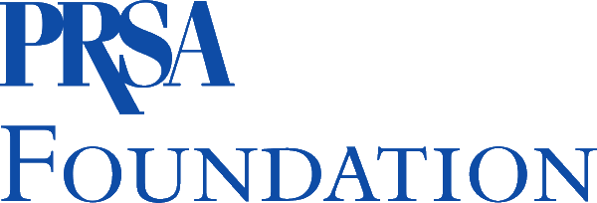
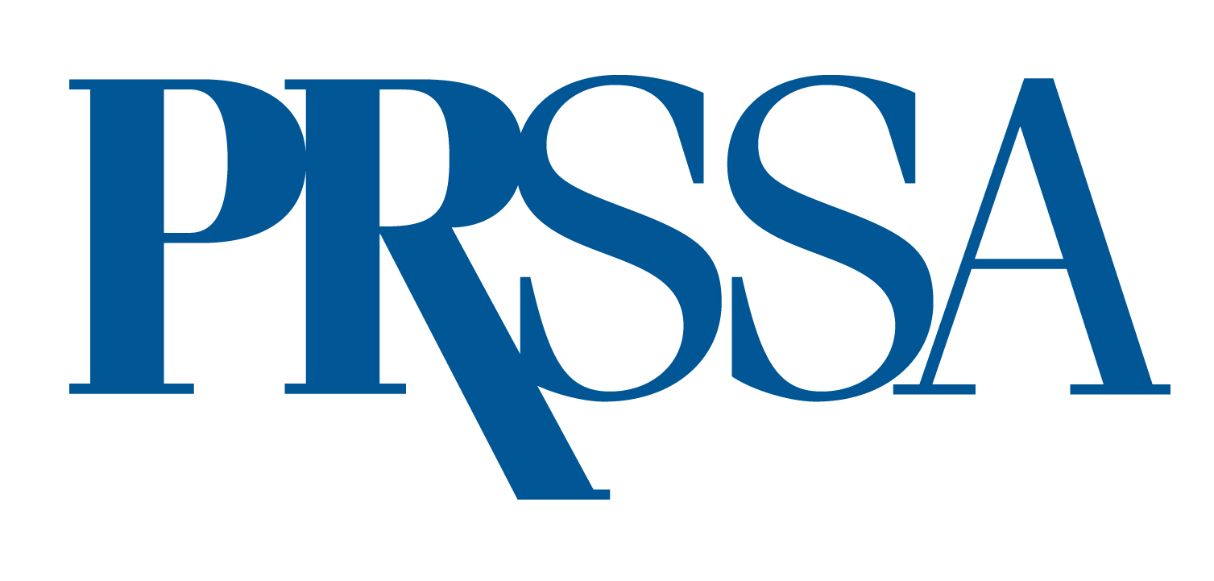

PRSA Foundation Student Travel Grant 2023

Application Timeline
Applications Open – Wednesday, April 12
Applications Closed – Wednesday, May 31
Notifications – Monday, July 31

The PRSA Foundation has allotted funds to encourage and support multicultural students majoring in, and planning to pursue, careers in public relations and related fields. This grant will support ten college students for up to $2,500 each to attend the PRSSA International Conference in Nashville, Tennessee, Oct. 13–17, 2023.

The grant will be used to offset the following expenses associated with International Conference attendance:

- Conference registration
- Travel
- Accommodations
- Meals not already provided through Conference registration (meals must not exceed $15 and receipt must be provided)

Description

At the Public Relations Student Society of America (PRSSA) International Conference, awardees will have the unique opportunity to walk among those who are leading the charge in the communications industry. PRSSA is about making connections and building relationships. The Conference programming provides awardees with numerous opportunities to interact with each other and build professional relationships by attending speaker sessions and networking with peers and professionals.

Awardees will also be able to attend the PRSA International Conference general sessions. Last year’s PRSA International Conference heard from well-known speakers such as reporter Katty Kay, football professional football icon Emmitt Smith and Academy Award winning actress Marlee Matlin.
The Nominees

- Five students from HBCU/HACUs or schools with significant multicultural populations with a PRSSA Chapter
- Five students from HBCU/HACUs or schools with significant multicultural populations without PRSSA Chapters

Application Materials
- Submit a completed application.
- Submit a resume.
- Submit a nomination letter, written by someone other than the nominee, who has firsthand knowledge of the student’s academic capabilities and interest in pursuing a career in public relations/communications. May be a public relations professional (corporate, agency, government, nonprofit) or higher education (college or university). Must be on official letterhead.
- Submit a typed, double-spaced essay of no more than 250 words on why it would be beneficial for you to attend this Conference.

Additional Requirements
- Grant recipients will be required submit a headshot and to write two blog posts about their experience and observations at the Conference for the PRSSA newspaper and the PRSA Foundation website.
- Additionally, students will be required to offer a meeting or luncheon on their campus to discuss some of the learnings from the Conference. This should take place before Dec. 30, 2023.

Make sure all materials are thoroughly proofread and error free. All application materials must be submitted via email to:

Ben Castleman
Student Programs Coordinator
PRSSA
Ben.Castleman@prsa.org
PRSA 2020 STUDENT TRAVEL GRANT
Application Form
Deadline: Sunday, May 31, 2020

Part One: Applicant Information

Applicant’s Full Name: ____________________________________________

Gender (check one): Female Male Birth Date: _______ / _______ / _______

College or University Name: ___________________________________________________

City: _________ State: _______ Classification (check one):

Freshman Sophomore Junior Senior

Major: _______________________ Minor: ______________________

Cumulative GPA (on 4.0 scale): _______ Anticipated Graduation Date: _____ / _____ / _____

School Mailing Address: ______________________________________________________

City: ___________________ State: _______ Zip: ____________

School Phone Number: _________________________________

School Email: _________________________________________

PRSSA Chapter School (check one): Yes No

Permanent Mailing Address: __________________________________________________

City: ___________________ State: _______ Zip: ____________

Permanent Phone Number: _____________________________

Permanent Email: _____________________________________

Race/Ethnicity (check one):

African-American Hispanic American/Latino

Asian-American Native American/American Indian

Pacific Islander Multiracial or Multiethnic (including at least one of the races/ethnicities listed above)

Other (specify):

Authorization:

I hereby certify that the information provided to the Public Relations Society of America for this grant application is accurate to the best of my knowledge. I understand that if the information is found to be false I will not be eligible to receive the grant.

Signature: ______________________________________ Date: _________________

Print Name: ___________________________________________________________

College/University: _____________________________________________________

Part Two: Application Materials
Please submit the following, along with this application form, by email to Jeneen Garcia, executive director, PRSSA, Jeneen.garcia@prsa.org.

- Resume
- Nomination letter, written by someone other than the nominee, who has firsthand knowledge of the student’s academic capabilities and interest in pursuing a career in public relations. May be a public relations professional (corporate, agency, government, nonprofit) or higher education (college or university). Must be on official letterhead.
- Typed, double-spaced essay of no more than 250 words on why it would be beneficial for you to attend this Conference.

All materials must be received by 12 p.m. EDT, May 31, to qualify. Late materials will not be accepted.

For further information, contact PRSSA at (212) 460-1474.

