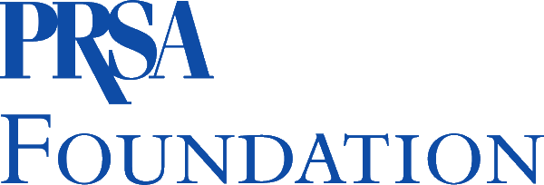


PRSA Foundation Student Leadership Assembly Travel Grant 2023

Application Timeline
Applications Open — Monday, March 6
Applications Deadline — Noon ET, Monday, March 13
Notifications — Tuesday, March 21

This grant was created to encourage and support multicultural students majoring in public relations and related fields who plan to pursue a career in public relations. The grant will support multicultural students attending the PRSSA Leadership Assembly, April 20—23, 2023 in in Scottsdale, Ariz. The grant will be used to cover Travel — Airfare to and from Leadership Assembly, up to $500.

Description

Each year, the PRSSA Leadership Assembly gathers to make influential, long-term decisions about the future of the Society, elect a new National Committee and review the bylaws. In addition, those who attend engage in leadership training and networking.

Application Requirements

Applicants must be current members of a PRSSA Chapter that is in good standing and in their junior year. Applicants must also already be registered for the PRSSA Leadership Assembly.

- A maximum of five students will be selected for this grant.

Application Requirements
- Submit a completed application.
- Submit a typed, double-spaced essay of no more than 200 words on why it would be beneficial for you to attend this Event.

Additional Requirements after Assembly
- Student will be required to write a blog post about their experience for the PRSSA blog and the PRSA and PRSA Foundation websites.
- Additionally, students will be required to offer a presentation during a meeting on their campus to discuss what they learned during the Assembly. This should take place before May 31, 2023.

Make sure all materials are thoroughly proofread and error free. All application materials must be submitted to Jeneen Garcia via email jeneen.garcia@prsa.org.
.
PRSA FOUNDATION STUDENT APPLICATION FORM
Deadline: Noon ET, March 13

Part One: Applicant Information

Fill in below, print and submit with the application materials required.

Applicant’s Full Name: ____________________________________________

College or University Name: ___________________________________________________

Classification (check one): Freshman Sophomore Junior Senior

Major: _______________________ Minor: ______________________

Cumulative GPA (on 4.0 scale): _______ Anticipated Graduation Date: ___ / ___ / ___

School Mailing Address: ______________________________________________________

City: ___________________ State: _______ Zip: ____________

School Phone Number: ___________________School Email: _________________________________

Permanent Mailing Address: __________________________________________________

City: ___________________ State: _______ Zip: ____________

Permanent Phone Number: ______________Permanent Email: ______________________________

Race/Ethnicity (check one):

African-American Hispanic American/Latino Asian-American

Native American/American Indian Pacific Islander

Multiracial or Multiethnic Other (specify): ___________________________________
(including at least one of the races/ethnicities listed above)

Authorization:

I hereby certify that the information provided to the Public Relations Society of America for this grant application is accurate to the best of my knowledge. I understand that if the information is found to be false, I will not be eligible to receive the grant.

Signature: ______________________________________ Date: _________________

Print Name: ___________________________________________________________

College/University: _____________________________________________________

All materials must be received by noon ET March 13. Late materials will not be accepted.
For further information, contact PRSSA at (212) 460-1474.

